
IBM Proposal for the
Gap NSI Reporting and Analytics Solution

Presented to Gap Inc.
By IBM Business Consulting Services
425 Market Street
San Francisco, CA 94105

Disclosure Statement
The information in this proposal shall not be disclosed outside the The Gap Inc. and shall not be duplicated, used or disclosed in whole or in part for the purpose other than to evaluate the proposal, provided that if a contract is awarded to IBM as a result of or in connection with the submission of this proposal, The Gap Inc. shall have the right to duplicate, use or disclose the information to the extent provided in the contract. This restriction does not limit the right of The Gap Inc. to use information contained in the proposal if it is obtained from another source without restriction. IBM retains ownership of this proposal.
IBM's products and services are proposed under the terms of the IBM Customer Agreement.
This proposal is valid for 30 days from the date of this response unless extended in writing by IBM.
Table of Contents
Executive Summary 2
1 Project Description and Scope 3
2 IBM Approach 4
2.1 Overview 4
2.2 Project Management 4
2.3 BI Strategy and Planning 5
2.3.1 Review Gap Business and IT Environment 5
2.3.2 Identify Solution Areas 5
2.3.3 Define Business Solution Strategy 6
2.3.4 Define Technical Solution Strategy 6
2.3.5 Outline Architecture Model 6
2.3.6 Assess Infrastructure Impact 7
2.3.7 Confirm BI Strategy and Planning 7
2.4 Solution Outline 7
2.4.1 Define Infrastructure Requirements 7
2.4.2 Define Architecture Model 8
2.4.3 Define Organization 8
2.4.4 Review Gap Environment 8
2.4.5 Outline Solution Requirements 9
2.4.6 Outline Application Model 9
2.4.7 Assess Business Impact 9
2.4.8 Outline the Solution Strategy 10
2.4.9 Solution Prototype 10
2.4.10 Confirm Solution Outline 10
2.5 Macro Design 11
2.5.1 Design Logical Data Repositories 11
2.5.2 Create Logical Data Integration Design 11
2.5.3 Create Logical Analytics Design 11
2.5.4 Create Logical Access Design 12
2.5.5 Design the Architecture Model 12
2.5.6 Design Solution Plans 12
2.5.7 Design Test Specifications 13
3 Project Timeline 14
4 Pricing, Project Assumptions, and Resource Plan 15
4.1 Project Pricing 15
4.2 Project Assumptions 16
4.3 IBM Resources and Role Descriptions 17
4.4 Project Resource Organizational Diagram 17

Executive Summary
IBM is pleased to present our response to The Gap’s request for assistance on NSI’s Reporting and Analytics project. It is our understanding that this environment is to be designed and implemented to provide The Gap with a common source of data, beginning with a consolidated view of store information and associated reporting for European Stores with additional analytics and reporting capability to be implemented for Europe and eventually additional countries. The architecture to be deployed must address the short term reporting needs while also establishing the foundation for The Gap’s long term data warehousing and Business Intelligence objectives.
- The Gap has defined the high level vision for its next generation data warehouse capability and the architecture toward which it intends to migrate over a multi-year timeframe. The Gap leadership team recognizes the importance of devising a well-formed and sustainable Data Warehouse/Business Intelligence (DW/BI) architecture to support, not only the immediate needs of the business under NSI, but also the next generation of data warehousing at The Gap that will enable cross business and country integration, as well as a new services delivery capability to support the new franchising model.
As you will see in the details of our response, IBM is proposing to provide several key capabilities that together, will enable The Gap to achieve both their short and longer term objectives. These capabilities include:
- An experienced team consisting of professionals from our business services and software teams that know your business, current information technology environment and where you want to go
- A proven methodology and approach to implementing retail industry specific business intelligence solutions
- Tools and technology that will enable the deployment of an integrated end-to-end architecture that can quickly address the current reporting issues while establishing a foundation that can be built upon to support longer term objectives
- Industry leading Business Intelligence capability that will allow us to present The Gap with multiple options that will help The Gap make informed decisions that better align with cost and benefit drivers.
- Implementation capabilities that will enable us to design the architecture and see it through to completion allowing The Gap to realize the business benefits with less risk.

In addition to these capabilities, several differentiators unique to IBM and our willingness to partner, will provide the Gap with an accelerated approach with less risk. These differentiators include the following:

- Knowledge of IBM’s Retail Data Warehouse (REDW) model which will be used to as a comparison and validation of business requirements by conducting a workshop subsequent to the end-to-end requirements sessions to validate the fit and value of the Retail Business Intelligence Solution for The Gap. The REDW can be a key accelerator that will change the traditional paradigm of requirements gathering to one that gets the organization to quickly focus on The Gap’s specific requirements. The Workshop and limited prototype to provided at no Charge to the Gap.
- A target architecture review using current infrastructure along with possible additional IBM tools and technologies knowledge that might make sense to lower cost and/or risk.

- A team with knowledge and experience across the key areas is critical to this engagement. This knowledge includes but is not limited to the technology and tools required to enable the architecture, understanding of the business issues facing the retail industry which we will provide through our industry based intellectual capital and research as well as functional knowledge of the subject areas being addressed by this project.

- Provide subject matter experienced resources to assist in the requirements gathering workshops – At no charge to Gap.

- Provide Todd Bixby, The Partner in charge of IBM’s Retail Business Intelligence Practice, with over 18 years of experience deploying business intelligence, reporting and data warehouse solutions will provide leadership and advise the delivery team through implementation. Todd’s experience includes projects with several large retail organizations including Starbucks, McDonald’s, Target, and Radio Shack. At no charge to Gap.

In summary, based on our work with the NSI reporting and analytics team to-date, and our knowledge of your business and technical environment, we are proposing an approach that can significantly reduce The Gap’s risks in meeting the aggressive timelines and business requirements of NSI..

Project Description and Scope
Gap Inc. is evaluating potential partners to provide consulting services and solutions in support of the design of an overall reporting and analytic information architecture framework that supports the NSI Merchandising Footprint. The Plan is to improve the usability and availability of data associated with the NSI rollout for Gap. The selected partner will assist with the planning, and design of the overall Enterprise Reporting and Analytics Architecture. The partner will assist in reviewing architecture, facilitating requirements gathering and provide assistance in the development of other key deliverables outlined within this document.
Specifically, the goals of the project are to design a robust and flexible architecture for the NSI Reporting and Analytics which will support business requirements with the Process areas included under Phase 1 and Phase 2 of The NSI rollout:
Phase 1:
- Retail Operations
- Customer Transactions
- Store Management
- Store Inventory Management
- Financial and Inventory Accounting
- Inbound Logistics
Phase 2:
- Planning
- In Season Management
- Allocation

Our Approach will be based on IBM’s standard Business Intelligence Methodology that has been used on many customer engagements for the design and deployment of a Enterprise reporting and analytics solutions. The Scope of this proposal includes activities in the BI Strategy and Planning, Solution Outline, and Macro Design phases of the IBM Global BI Method. We have customized our methodology to meet Gap’s specific requirements and to specifically integrate our approach with efforts already underway at Gap. A detailed discussion of our approach is included in the following section.

IBM Approach

Overview
IBM understands the project goals, objectives and will continue to work with The Gap to define the scope. We have provided an approach that will assist The Gap in achieving the objectives of the project with lower overall risk. IBM’s approach to designing and developing BI solutions is multi-phased; each phase building upon those that preceded it. The major activities of our standard approach across the entire BI project lifecycle are depicted in the figure below for completeness and although are represented in sequential fashion, our detailed methodology, workplans and sample deliverables allow us to execute many activities in parallel. The Scope of this proposal includes activities in the BI Strategy and Planning, Solution Outline, and Macro Design phases of the IBM Global BI Method as depicted within the red box below.

Standard Methodology
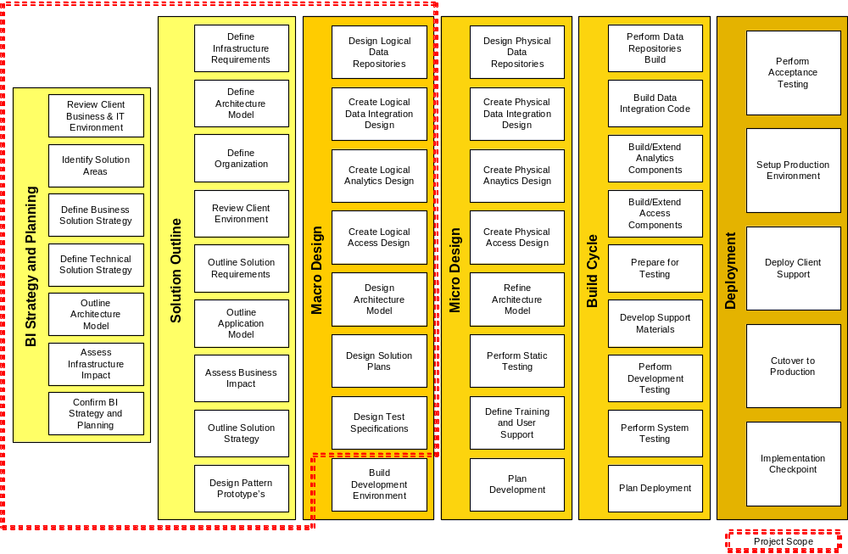
We have customized our methodology to meet Gap’s requirements and to specifically integrate our approach with efforts already underway at Gap. A detailed outline of the activities included in this proposal follows:

Project Management
IBM will provide project management for the IBM responsibilities in this Statement of Work. The purpose of this activity is to provide technical direction and control of IBM project personnel and to provide a framework for project planning, communications, reporting, procedural and contractual activity. IBM will perform the following tasks:
Planning
- Review the Statement of Work and the contractual responsibilities of both parties with the Gap Project Manager.
- Maintain project communications through the Gap Project Manager.
- Coordinate the establishment of the project environment.
- Establish documentation and procedural standards for Deliverables.
- Prepare and maintain the project plans for performance of this Statement of Work, which defines the activity, task, responsibilities, milestones and estimated schedule.
- Prepare for the NSI Reporting and Analytics project team orientation.
Project Tracking and Reporting
- Measure and evaluate progress against the Project Plan with the Gap project manager.
- Resolve deviations from the Project Plan with the Gap Project Manager.
- Conduct regularly scheduled project status meetings.
- Prepare and submit a Status Report bi-weekly to the Gap project manager.
- Administer the Project Change Control Procedure with the Gap project manager.
- Coordinate and manage the technical activities of the project personnel.
- Review project tasks, schedules, and resources and make changes or additions, as appropriate.
Deliverables:
- Bi-weekly Status Reports

BI Strategy and Planning

Review Gap Business and IT Environment
The purpose of this activity is to review existing documentation of client strategies, initiatives, systems etc in order to gain an understanding of the business, organization, and IT environment in preparation for identifying BI opportunities and developing several solution areas.
Based on the interviews conducted, IBM will work with Gap to perform the following:
- Define Business Context (Interviews, workshops, research)
- Identify High Level Business Requirements
- Define Business Issues and Goals
Deliverables:
- High-Level Current Environment Assessment

Identify Solution Areas
The purpose of this activity is to identify one or more solution areas, where each solution area represents a discrete project initiative with its own set of objectives, scope and intent. There is an initial prioritization of each defined solution area based on its relative importance and benefit to the business.
IBM will develop an NSI Reporting and Analytics Solution Strategy document which outlines the following:
- Identify Opportunities and Desired Capabilities
- Outline Capability Enablers
- Identify Capability Gaps Shortcomings and Deficiencies
- Outline High Level Subject Area Model (BI)
- Outline Solution Areas
Deliverables:
- High-level Subject Area Model

Define Business Solution Strategy
The purpose of this activity is to define the overall solution strategy based on the set of specific solution areas that offer value. This activity is performed in order to assemble the solution strategy according to solution area.
IBM will develop a NSI Reporting and Analytics Solution Strategy document which outlines the following:
- Define Solution Area Impact
- Develop Solution Area Release Plan (Roadmap)
Deliverables:
- Solution Definition, Solution Roadmap

Define Technical Solution Strategy
The purpose of this activity is to capture decisions about how business processes will be supported, identifies the scope of the system, and outlines infrastructure requirements.
The IBM team will perform the following:
- Outline User Profiles
- Outline Metadata Strategy
- Refine Subject Area Model (BI)
- Review Data Availability and Quality
- Review External Data Reference Definition
- Define and Categorize Infrastructure Requirements
Deliverables:
- Technical Solution Strategy

Outline Architecture Model
The purpose of this activity is to define a high-level draft of the architecture and establish a framework which guides the implementation of business intelligence solutions. It serves as the basis for the evaluation and planning of the end-state infrastructure. It ensures that the architecture is robust and flexible for the overall systems (all releases), which can easily adapt to changing business requirements.
The IBM team will perform the following:
- Review High-Level Architecture Overview
- Review High-Level Component Model
- Review High-Level Operational Model
- Review Service Levels
- Reference Architecture Asset Gap Analysis
Deliverables:
- Reference Architecture

Assess Infrastructure Impact
The purpose of this activity is to identify the gaps between the existing and required technologies, networks, IT processes, and IT skill sets, in terms of how they perform today and how likely they will meet the future business needs. This information is an essential prerequisite in planning the activities to build and support the future IT infrastructure.
The specific tasks to be performed by IBM in this activity are defined in the sections below:
- Confirm Solution Areas Post Infrastructure Planning Impact
- Confirm Solution Area Release Plan
Deliverables
- BI Roadmap

Confirm BI Strategy and Planning
The purpose of this activity is to develop the overall strategy for moving forward with the solution outline, design and development effort, and gain client agreement to a BI Strategy and Plan (roadmap).
The specific tasks to be performed by IBM in this activity are defined in the sections below:
- Assemble Phase Deliverables
- Review Phase Deliverables
- Prepare Submission of Deliverables
- Harvest Reusable Assets
- Manage Acceptance
Deliverables
- BI Strategy

Solution Outline

Define Infrastructure Requirements
The purpose of this activity is to outline the requirements for the system and ensure that all future decisions reflect the business priorities.
The specific tasks to be performed by IBM in this activity are defined in the sections below:
- Develop Metadata Strategy
- Refine Subject Area Model (BI)
Deliverables:
- Metadata Strategy
- Provide feedback on current Architecture Model (Document)

Define Architecture Model
The objective of this activity is to formulate a high level, conceptual vision of the architecture for the overall NSI Reporting and Analytics Solution. It will ensure that the architecture is robust and flexible for the overall systems (all releases), which can easily adapt to changing business requirements, ensure that the architectural solution can meet business requirements and non-functional requirements, and provide a basis for detailed estimation and planning of the end-state infrastructure.
The specific tasks to be performed by IBM in this activity are defined in the sections below:
- Review Reusable Components/Templates
- Review the High-Level Component Model
- Review the High-Level Operational Model
- Review Architecture Overview
- Review Survey of Available Assets
- Review Service Level Analysis
- Review BI Reference Architecture Asset Gap Analysis
- Refine Viability Assessment
Deliverables:
- Provide feedback on current Architecture Model (Document)

Define Organization
The purpose of this activity is to identify the gaps between the existing and required technologies, networks, IT processes, and IT skill sets, in terms of how they perform today and how likely they will meet the future business needs. This information is an essential prerequisite in planning the activities to build and support the future IT infrastructure.
The specific tasks to be performed by IBM in this activity are defined in the sections below:
- Review Organization Gap Analysis
- Review IT Readiness Assessment
- Review IT Organization Skills Gap Analysis
- Review Job Roles and Responsibilities and Competencies
- Review Model of Process Strategy and Approach (BI)
Deliverables:
- Review and Comment on IT Organizational Strategy

Review Gap Environment
The objective of this activity is to gain an understanding of the Gap business, organization and current I/T environment in preparation for recommending the NSI Reporting and Analytics solution.
IBM will conduct 10 interviews with identified NSI Reporting and Analytics stakeholders, and facilitate the reporting portion of 12 End to End process workshops. The IBM Project Manager will work with the Gap Project Manager to determine the actual interviews and workshops to be conducted.
The specific tasks to be performed by IBM in this activity are defined in the sections below:
- Classify Business Terms
- Define Business Context
- Obtain or Develop Business Models
- Validate Business Issues And Goals
- Document IT Standards
- Analyze Current IT Infrastructure
Deliverables:
- Organizational Strategy

Outline Solution Requirements
The purpose of this activity is to outline the requirements for the system based upon the completed stakeholder interviews and end to and process workshops and ensure that all future decisions reflect the business priorities.
The specific tasks to be performed by IBM in this activity are defined in the sections below:
- Establish System Context
- Evaluate Current Solution
- Gather and Categorize Requirements
- Work on Key Use Cases
- Assess Initial Viability
Deliverables:
- Business and IT Requirements

Outline Application Model
The purpose of this activity is to help understand the complexity of the system.
The specific tasks to be performed by IBM in this activity are defined in the sections below:
- Establish Analysis Guidelines
- Define Conceptual Data Model
- Outline System Functions
- Outline Process/Data Usage Matrix
- Confirm External Data Reference Definition
- Assess Data Sources
Deliverables:
- Conceptual Data Model
- Source System Inventory

Assess Business Impact
The purpose of this activity is to verify engagement feasibility (IBM "due diligence") and ensure the expected organization change is planned for and addressed in the later phases of the project.
The specific tasks to be performed by IBM in this activity are defined in the sections below:
- Develop Organization Change Readiness Assessment
- Develop IT Readiness Assessment
- Confirm Solution Area
Deliverables:
- Review and comment on the Organizational Strategy

Outline the Solution Strategy
The purpose of this activity is to ensure a shared understanding of the appropriate engagement process for the remaining phases, provide context and rational for the estimate, and provide a basis for planning of the development effort.
The specific tasks to be performed by IBM in this activity are defined in the sections below:
- Sketch Release Plan
- Sketch Deployment Plan
- Sketch System Management Plan
- Setup Configuration Management Procedures
- Define Test Strategy
- Review Education and Training Strategy
Deliverables:
- Deployment Plan
- Test Strategy
- Review and Comment on Education and Training Strategy

Solution Prototype
The purpose of this activity is to demonstrate the proof of value associated with the IBM RBIS solution to assist the Gap in determining the approach for subsequent project phases:
The specific tasks to be performed by IBM in this activity are defined in the sections below:
- Develop a prototype leveraging the IBM RBIS Solution
- Review and present our RBIS Prototype for one process area based upon IBM’s solution
- Facilitate an RBIS Workshop to understand the value of the RBIS solution specifically for Gap
Deliverables
- Prototype
- RBIS Workshop

Confirm Solution Outline
The purposes of this activity are to re-estimate the project effort, package the major deliverables, identify any risks, verify that Gap is still committed to the remaining NSI Reporting and Analytics project efforts, and prepare the detailed project plan and budget for the Macro Design phase.
The specific tasks to be performed by IBM in this activity are defined in the sections below:
- Package all project Deliverables for final delivery
- Re-estimate the project efforts, and develop the project plan the Macro Design phase (Project Management Schedule, Project Estimates)
- Conduct a review of the project Deliverables and review the project status
Deliverables
- Macro Design Project Plan

Macro Design

Design Logical Data Repositories
This activity defines the logical framework in terms of the short-term and long-term strategy for the logical data models (e.g. operational reporting databases to OLAP structures) necessary for the planned business intelligence environment.
IBM will work with Gap to:
- Review Logical Data Repositories Architecture
- Develop the High-Level Operational Data Store Logical Data Model
- Develop the High-Level Data Warehouse Logical Data Model
- Develop the High-Level Data Mart Logical Data Model
- Identify DQ Criteria from the Logical Data Models
- Define the approach to Capture Logical Data Model(s) Business Metadata
Deliverables:
- Logical Subject Area Data Model
- Logical Data Repositories Architecture (DW, ODS, Data Marts)

Create Logical Data Integration Design
This activity defines the logical data integration specifications necessary to meet the business requirements of data integration and movement for both the short-term and long-term projects in terms of frequency, integration, and data quality, for the planned business intelligence environment.
IBM will work with Gap to:
- Establish Logical Data Integration Architecture
- Create Logical Data Integration Model (e.g. Data Flow Diagram)
- Review/Assess Source Data Quality
- Develop Logical Transform Design
- Develop Logical Load Design
- Develop One-Time Data Conversion
- Develop Logical Source-To-Target Model
- Capture Logical Data Integration Model Navigational Metadata
Deliverables:
- Logical ETL/EAI Design
- High Level Source data quality assessment
- Data Transformation Business Rules (Business Rules Specification for KPI’s)
- Logical Source-Target Mapping (Source level Data Mapping Analysis)

Create Logical Analytics Design
This activity defines the logical analytic specifications and/or prototype necessary to confirm the reporting, ad-hoc query, and analytic business requirements of planned business intelligence environment for both short-term and long-term projects.
IBM will work with Gap to:
- Establish Analytics Design Guidelines
- Review User Requirements
- Review Delivery Services Architecture
Deliverables:
- Logical Analytics Design

Create Logical Access Design
This activity defines the logical access specifications in order to determine the access method (e.g. portal, web browser).
IBM will work with Gap to:
- Review Web Browser Approach
- Review Portal Approach
- Review Device Approach
- Review Access Architectural Models
Deliverables:
- Logical Access Design

Design the Architecture Model
The purpose of this activity is to design a robust and flexible architecture for the overall system which will support business requirements and can easily adapt to changing business requirements, assess the viability of the system, provide a basis for detailed estimation and planning for the first release of the system, provide a basis for designing and implementing individual releases of the system, and avoid duplicate or "throw away" development effort within the releases by taking into account the dependencies between the functionality of the releases.
IBM will work with Gap to:
- Evaluate Candidate Assets
- Determine Deployment Units
- Develop Operational Model
- Specify Stereotypical Interactions
- Refine Architecture to Accommodate Change Cases
- Reference Architecture Asset Gap Analysis
- Evaluate Infrastructure Products
- Select Infrastructure Products
- Develop Performance Model
- Analyze Service Levels (BI)
- Update Operational Model
- Refine Viability Assessment
- Asset Reuse Candidates
- Review IT Organization Skills Gap Analysis
Deliverables
- Metadata Environment

Design Solution Plans
This activity develops the system test plan, develops the usability and evaluation plan, develops at a high level the education and training plan, to include responsibilities and deliverables, and develops the deployment plan.
IBM will work with Gap to:
- Develop Release Plan
- Create or Extend Education and Training Plan
- Revise Deployment Plan
- Refine System Management Plan
- Develop Acceptance Test Plan
- Develop Operability Test Plan
- Develop Integration Test Plan
- Develop System Test Plan
- Refine Cost/Benefit Analysis
- Confirm Solution Area Post Macro Design Impact
Deliverables:
- Refined Plans

Design Test Specifications
This activity defines the logical access specifications in order to determine the access method (e.g. portal, web browser).
IBM will work with Gap to:
- Design Acceptance Test Approach
- Design Operability Test Approach
- Design Systems Integration Test Approach
- Design System Test Approach
- Identify Test Environment Requirements
Deliverables:
- Refined Plans

Project Timeline
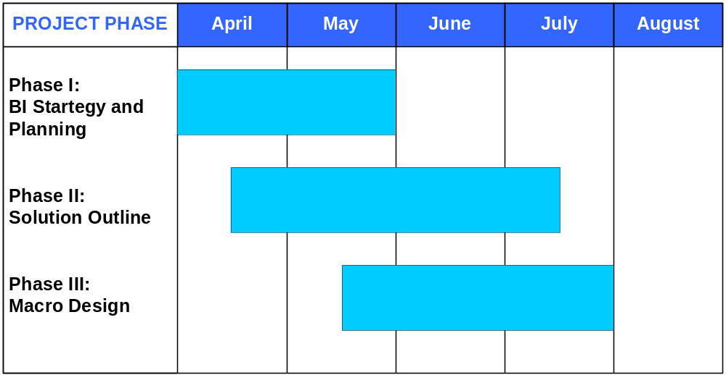

Pricing, Project Assumptions, and Resource Plan

Project Pricing
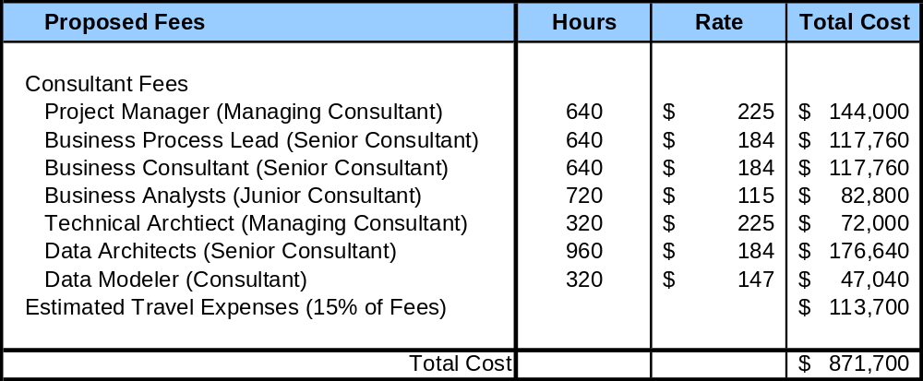

This project will be conducted on a time and materials basis. IBM will provide an estimated {Number of hours} hours for the Services at an hourly rate of {Hourly rate}. The estimated professional services charges for this Statement of Work are {Fee total} and are exclusive of any travel and living expenses, other reasonable expenses incurred in connection with the Services, and any applicable taxes. Any estimate given by IBM of any charge whether for planning or any other purpose is only an estimate and is not contractually binding.
{CUSTOMER NAME} will be billed actual travel and living costs estimated at {Travel fee estimate} % of professional services charges.
IBM will invoice {CUSTOMER NAME} for actual Services hours worked, whether above or below the estimated hours, applicable taxes, travel and living expenses and other reasonable expenses incurred in connection with the Services.
Payment is due upon receipt of invoice. In the event of late payment, IBM reserves the right to suspend the provision of Services and to charge interest on amounts overdue.

Project Assumptions
Our estimates assume that Technical Architecture Components are selected by the end of phase 1 of the methodology and that the Technical Architecture and Strategy areas are completed as represented by the chart below:
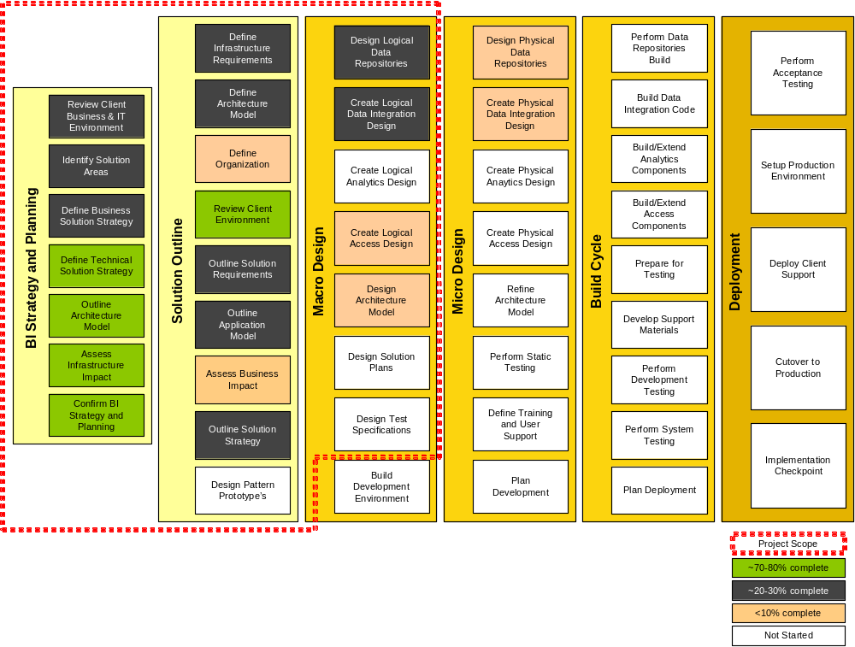

IBM requires the following Gap resources for the duration of the project:

- Project Manager (full-time)
- Project Sponsor (one day/week)
- Business Area SMEs (e.g. Finance, HR, Multi-channel) (1 per functional area 10% of time)
- IT Business functional area expertise consistent with the areas associated with NSI (1 per functional area, 50% of time) with one full time lead with knowledge of the current data sources
- Technical Architect to lead and own technical architecture and decisions
- Technical resources to drive architecture and design
- DBA to participate in design review and validation
- ETL personnel (one day/week to run record counts/reports, etc)
- Unix system administrator (full time initially during installs, 50% after installs completed)
- Establishment of a NSI BI steering committee within the first 6 weeks of the project.

IBM Resources and Role Descriptions
Project Partner: Responsible for the overall delivery of the project and the relationship with the Gap project sponsor.
Project Manager: Responsible for the delivery of the project and the day-to-day interface with the delivery team and the Gap project manager.
Business Process Lead: Review current reporting processes and business requirements. Identify process improvement opportunities. Ensure business requirements are integrated into BI solution. Recommend process changes.
Business Analyst: Business requirements gathering for the finance reporting. Assist process lead with analyses. Interface with the business areas.
Technical Architect: IT professional with an appreciation of business content and BI architectural considerations.
Data Analyst: Data modeler with specific skills in the field of decision support/BI data modeling constructs within Retail environments. Solid understanding of business context and terms.

Project Resource Organizational Diagram
Below is the suggested project organizational structure. Engagement team resources named in this proposal will be held for this engagement through January 15, 2006. IBM may have to substitute similar resources if an agreement between IBM and The Gap is not reached by January 15, 2006.
